**Extended Response Task 2:** Weighting 5%

**Chromatography and Polarity**

Name _____________________________ Due: _____________________

### **Science as a Human Endeavour - Intermolecular forces and gases**

### Chromatographic techniques, including thin layer chromatography (TLC), gas chromatography (GC), and high performance liquid chromatography (HPLC), are used to determine the components of a wide range of mixtures in various settings. The decision to use a particular chromatographic technique depends on a number of factors, including the properties of the substances being separated, the amount of substance available for analysis and the sensitivity of the equipment. Chromatographic techniques have a wide range of analytical and forensic applications, including monitoring air and water pollutants, drug testing of urine and blood samples, and testing for food additives and quality.

**Science Understanding**

Data from chromatography techniques, including thin layer chromatography (TLC), gas chromatography (GC), and high-performance liquid chromatography (HPLC), can be used to determine the composition and purity of substances; the separation of the components is caused by the variation in strength of the interactions between atoms, molecules or ions in the mobile and stationary phases

interpret a range of scientific and media texts, and evaluate processes, claims and conclusions by considering the quality of available evidence; and use reasoning to construct scientific arguments

* communicate to specific audiences and for specific purposes using appropriate language, nomenclature and formats, including scientific reports

**Part A: Chromatograph Research and Questions**

1. For each of the three types of chromatography

* Thin Layer Chromatography (TLC)
* Gas Chromatography (GC)
* High-performance liquid chromatography (HPLC)

Explain how the process of each works to separate the individual components of a mixture, its uses and the advantages and disadvantages of each.

Include the following terms in your explanation; mobile phase, stationary phase, solvent and retention factor (Rf).

2. Complete the chromatography questions on this task.

**Part B: Chromatography and Polarity Validation**

You will then sit a validation based on the three chromatography techniques and questions similar to those in Part A .

**Questions**

1. Substance A is made up two components. O and P. A small sample of substance A was

dotted onto chromatography paper, and a chromatogram was developed using an

appropriate solvent. The result is shown below.

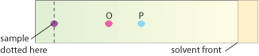

Component O is adsorbed:

a) less strongly onto the stationary phase and has a larger Rf value than component P.

b) more strongly onto the stationary phase and has a larger Rf value than component P.

c) less strongly onto the stationary phase and has a smaller Rf value than component P.

d) more strongly onto the stationary phase and has a smaller Rf value than component P.

2. Which of the following statements about chromatography is correct?

a) Paper chromatography and gas chromatography are both routinely used for quantitative analysis only.

b) Paper chromatography is usually considered to be qualitative only, while gas chromatography can be qualitative or quantitative.

c) Paper chromatography and gas chromatography are both routinely used for qualitative analysis only.

d) Paper chromatography is usually considered to be quantitative only, while gas chromatography can be qualitative or quantitative.

3. Which of the following is the most suitable gas to use as a carrier gas in a gas chromatogram?

a) helium

b) carbon dioxide

c) methane

d) oxygen

4. Thin layer chromatography can be used to distinguish between different amino acids. If a particular amino acid has low solubility in the mobile phase used, then the amino acid:

a) will spend more time dissolved in the mobile phase than attached to the stationary phase.

b) will move at a speed close to that of the solvent.

c) must have a high molecular mass.

d) will have a low Rf value.

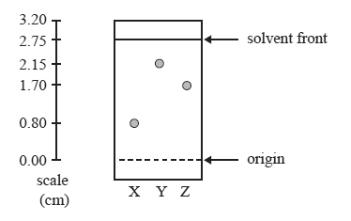5. Consider the following TLC plate of compounds X, Y and Z developed using a suitable mobile phase on a polar stationary phase.

The Rf value of the most polar component in this TLC separation is

a) 0.29  
b) 0.62  
c) 0.78  
d) 0.80

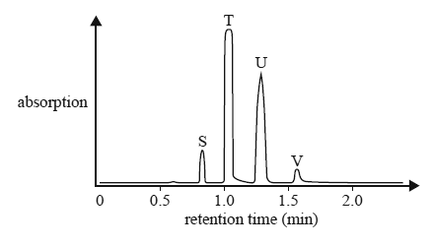6. Four straight chain alkanols, S, T, U, V, with a general formula ROH, were analysed using a gas chromatograph combined with a mass spectrometer. The following chromatogram was produced.

What is the order of the alkanols from the highest molar mass to the lowest molar mass?

a) V, U, T, S  
b) T, U, S, V  
c) V, S, U, T  
d) S, T, U, V

Deadly diseases such as tetanus, botulism and gangrene are caused by related groups of bacteria (clostridium genus) found in the soil. Each group of bacteria produces specific volatile fatty acids. These fatty acids can be identified using gas chromatography by comparison with a control chromatogram of known standards.

The following gas chromatogram is of the fatty acids produced by one such group of bacteria.

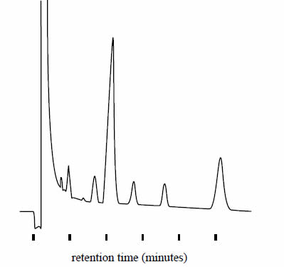

7. The identity of the fatty acids can be determined by measuring

a) their retention times.  
b) the temperature of the column.  
c) the flow rate of the carrier gas.  
d) the area under each of the peaks.

8. The relative amount of each of the fatty acids can be determined by measuring

a) their retention times.  
b) the temperature of the column.  
c) the flow rate of the carrier gas.  
d) the area under each of the peaks.

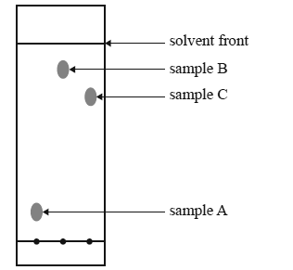9. The thin layer chromatography plate shown below has a polar stationary phase. It was developed using hexane as the solvent.

Which sample has the most polar molecules?

Explain your answer.

10. Calculate the Rf values for each of the dots in the first column. Start with the lowest dot.

|  |  |  |
| --- | --- | --- |
| Distance traveled by compound (cm) | Distance traveled by solvent  (cm) | Rf values |
|  |  |  |
|  |  |  |
|  |  |  |
|  |  |  |

11. High-performance liquid chromatography is used to determine the amount of caffeine in a sample of a soft drink. The chromatogram below shows the detector response when a standard solution of caffeine with a concentration of 200 mg L–1 is measured using the instrument.

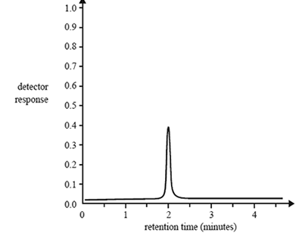

a) What is the retention time of caffeine in this experiment?

b) On the chromatogram above, sketch the detector response when a commercial soft drink with a caffeine content of 350 mg L–1 is measured using the same instrument.

12. A Trading Standards scientist tests some children’s toys to make sure that the toys are not coloured with harmful dyes.

He tests the colours from five different toys (A – E) and a harmful dye using paper chromatography. His results are shown below.

1. The solvent front moves 9cm and the single spot from the harmful dye moves 3.6 cm.

Calculate the Rf value of the harmful dye.

1. Draw the spot from the harmful dye in the correct position on the diagram.
2. Use the chromatograph to decide which one of the toys (A-E) should not be sold to the

public. Explain your answer.

13. Chromatography is used by the ‘Horse Racing Forensic Laboratory’ totest for presence of illegal drugs in racehorses.

A concentrated sample of urine is spotted onto chromatography paper on the start line. Alongside this, known drugs are spotted. The chromatogram is run using methanol as the solvent. When finished, the paper is read by placing under ulta-violet light. A chromatogram of urine from four racehorses is shown.

a) Calculate the Rf values for the known drugs.

b) State two factors which determine the distance a substance travels up the paper.

c) From the results one horse sample contains an illegal drug

(i) State the horse and the drug present

(ii) Give a reason for the use of this drug

14. A forensic chemist wants to test the accuracy of a gas chromatograph that is to be used for the analysis of blood alcohol content.  
A blood sample may contain a number of volatile chemicals that can interfere with the identification and measurement of ethanol in the blood. A sample containing a mixture of ethanol and several other volatile chemicals was injected into the gas chromatograph. The following chromatogram was obtained.

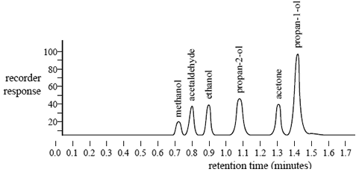

The forensic chemist claims that the presence of these volatile chemicals would not affect

the qualitative analysis of ethanol.

a) What evidence is presented in the chromatogram to support this claim?

b) To determine the percentage of alcohol in a blood sample only the peak at a retention time of

0.9 minutes is measured. Explain why.

c) The following calibration graph was constructed using simulated standard blood alcohol samples ranging in concentration from 0.000% to 0.400% m/v ethanol. Each standard was run through the chromatography column and the area under the peak produced at a retention time of 0.9 minutes was measured.

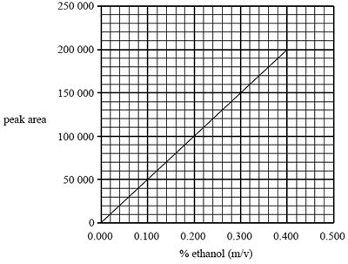

The blood alcohol content of a car driver was determined using this chromatographic technique. Determine the percentage (m/v) of alcohol in the driver's blood if the peak area at a retention time of 0.9 minutes was found to be 110 000.

15. Caffeine is a stimulant drug that is found in coffee, tea, energy drinks and some soft drinks. The concentration of caffeine can be determined using HPLC. 25 micro-litre samples of various drinks thought to contain caffeine were then separately passed through the HPLC column. The results are shown below.

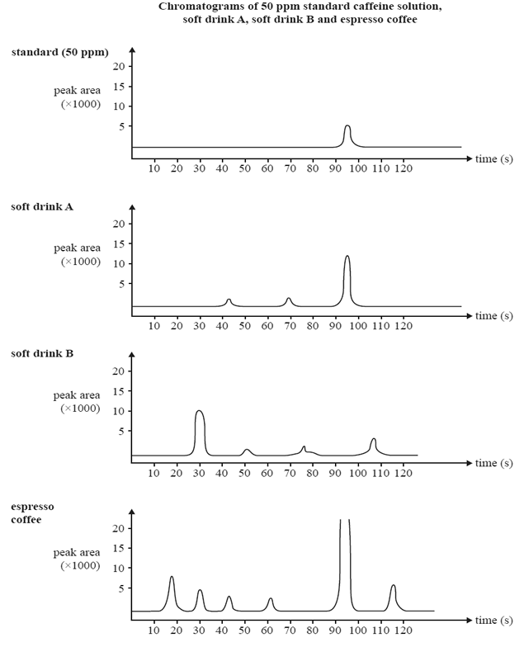

1. What evidence is presented in the chromatogram that supports the conclusion that soft drink

B does not contain any caffeine?

b) Explain why the caffeine content of the espresso coffee sample cannot be reliably determined using the information provided.

c) Describe what can be done to the espresso coffee sample so that its caffeine content can be reliably determined using the information provided.